4. ReactJS-HOL

Solution:

1. **Created a new react application** using: **npx create-react-app blogapp**

2. Open the application using VS Code

3. **Created a new file** named as **Post.js** in src folder with following properties:

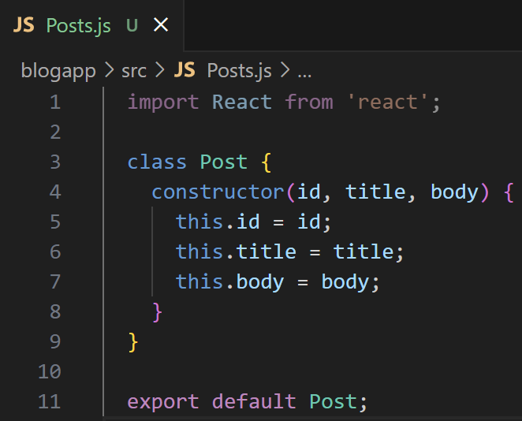

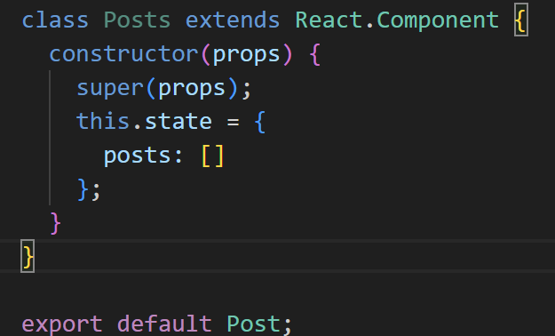4. Created a new **class based component** named as **Posts** inside Posts.js file

**5. Initialized the component** with a **list of Post** in **state** of the component using the constructor

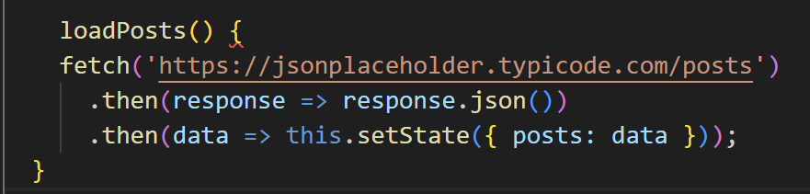**6**. **Created a new method** in component with the name as **loadPosts()** which will be responsible for using **Fetch API** and assign it to the component state created earlier. To get the posts use the url : (<https://jsonplaceholder.typicode.com/posts>)

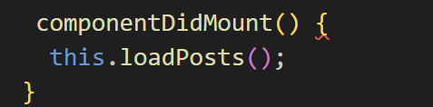7. **Implement** the **componentDidMount()** **hook** to make calls to loadPosts() which will fetch the posts

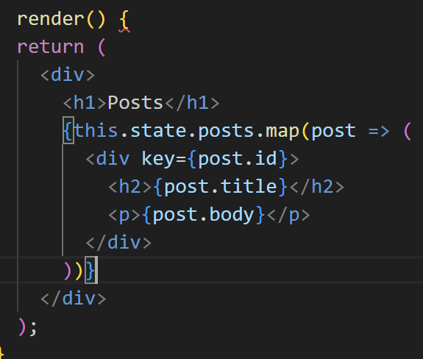**8**. **Implement** the **render()** which will display the title and post of posts in html page using heading and paragraphs respectively.

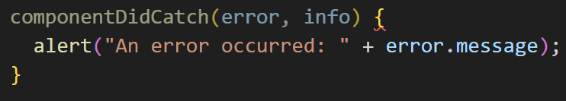**9**. Define a **componentDidCatch()** **method** which will be responsible for displaying any error happing in the component as alert messages.

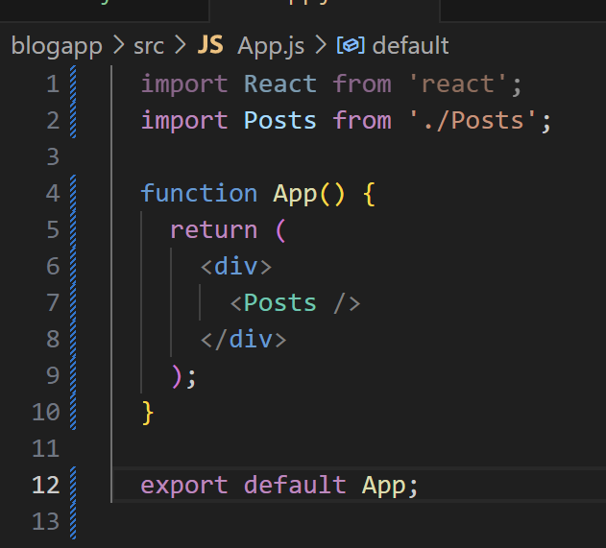10**. Add** the **Posts component** to **App component** in **App.js**

11.  **Run the application** using **npm start** command.



